Sprint [1] UI Prototypes

[US-101 & US-102]: [Public User Account]
As a public user, I want to be able to create my own unique profile with my personal profile picture, user name, contact email and phone number. So that I may properly access the functionalities offered and manage my condo(s).

As a user, I want to be able to log out and into my account, so I can access the contents of my account at any time.

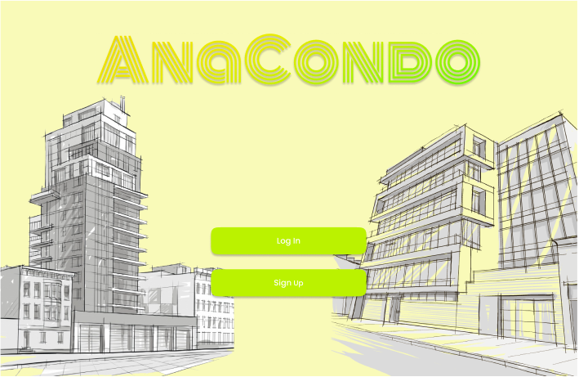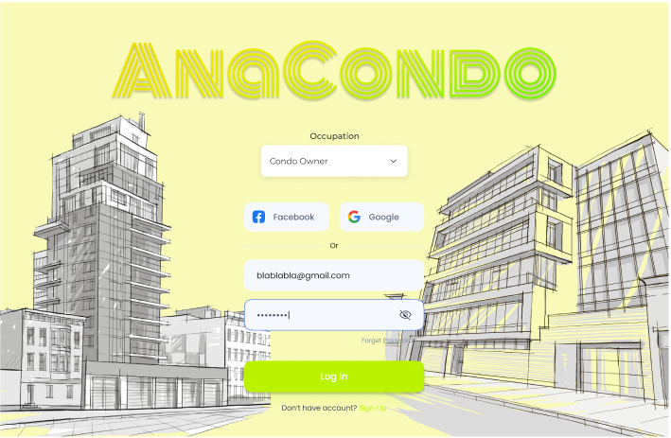
Starting Page Log In Page
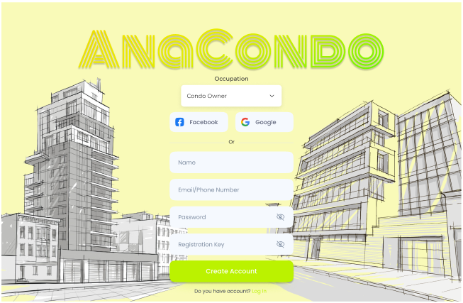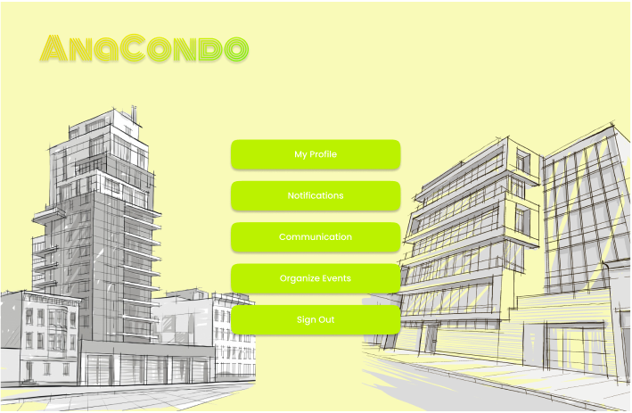
Sign Up Page Public User Home Page
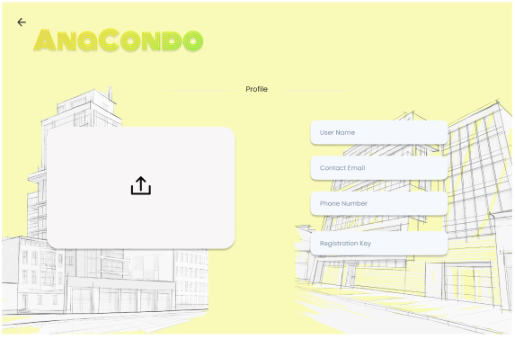
My Profile Page
Steps:
- The user accesses the application’s starting page and selects “Log In” or “Sign Up”
- The user fills in the form with their email and password.
- The user selects the “Log In” button.
- The user fills in the form with their email and password.
- The user selects the “Create Account” button.
- The user is redirected to their home page.
- The user selects “My Profile” to customize their profile.
- The user goes back to the main page and selects “Sign Out” to log out of their account.

[US-103]: [Condo Owner Account]
As a condo owner,
I want to be able to create a condo owner account with a registration key,
So that I may access the condo owner functionalities such as managing my condo(s).

Starting Page Log In Page
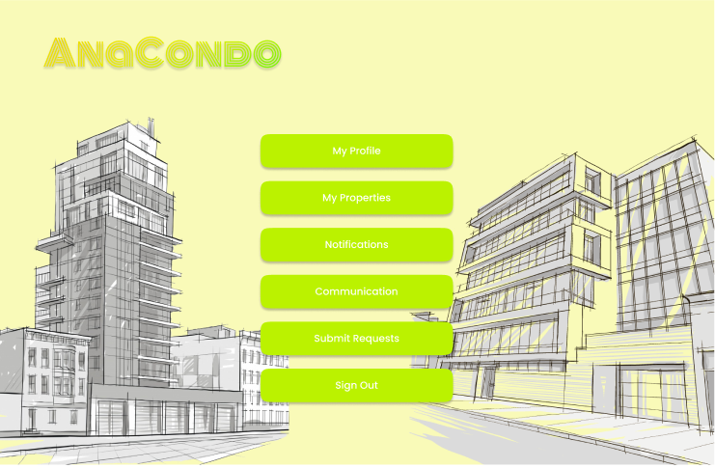
Sign Up Page Condo Owner Home Page
Steps:
- The user accesses the application’s starting page and selects “Log In” or “Sign Up”
- The user fills in the form with their email and password.
- The user selects the “Log In” button.
- The user fills in the form with their email and password.
- The user selects the “Create Account” button.
- The user is redirected to their home page.

[US-104]: [Rental User Account]
As a rental user,
I want to be able to create a rental user account with a registration key,
so that I may access the rental user functionalities.
Starting Page Log In Page
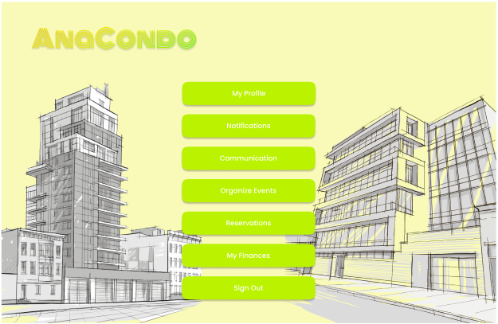
Sign Up Page Rental User Home Page
Steps:
- The user accesses the application’s starting page and selects “Log In” or “Sign Up”
- The user fills in the form with their email and password.
- The user selects the “Log In” button.
- The user fills in the form with their email and password.
- The user selects the “Create Account” button.
- The user is redirected to their home page.

[US-105]: [Employee User Account]
As an employee of one of the condominiums, I want to create an account where I may have access to an employee dashboard listing my employee role, so that I may access the current requests submitted by the condominium manager and/or the condo company administration.
Starting Page Log In Page
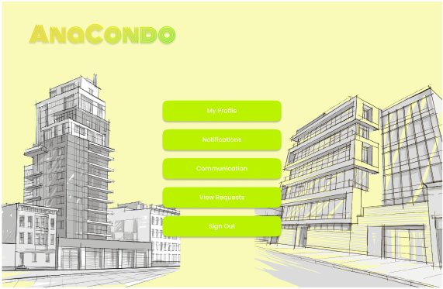
Sign Up Page Employee User Home Page
Steps:
- The user accesses the application’s starting page and selects “Log In” or “Sign Up”
- The user fills in the form with their email and password.
- The user selects the “Log In” button.
- The user fills in the form with their email and password.
- The user selects the “Create Account” button.
- The user is redirected to their home page.

[US-106]: [Dashboard of Properties]
As a condo owner,
I want to view all my properties in an easy-to-navigate and minimalist interface,
So that I may know the remaining balance on my monthly condo fee payments, status of submitted requests and general condo information on my properties.
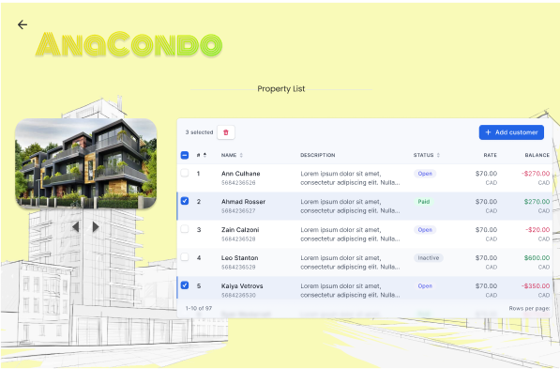
Condo Owner Home Page Properties Page
Steps:
- The Condo Owner user selects “My Properties”
- The user chooses which property they want to have information displayed about.

[US-207]: [Condo Management Company Account]

As a condo management company administrator, I want to create a profile for our properties, so that we may manage our property profiles.
Starting Page Log In Page
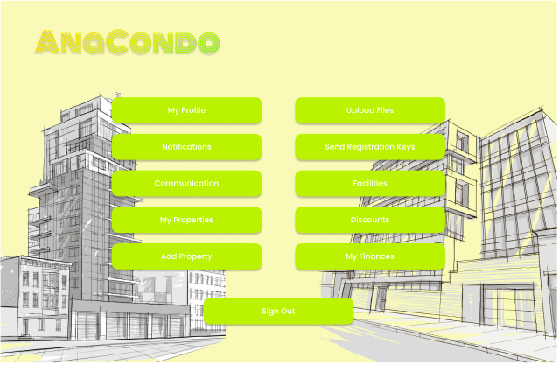
Sign Up Page Condo Management Company Administrator Home Page
Steps:
- The user accesses the application’s starting page and selects “Log In” or “Sign Up”
- The user fills in the form with their email and password.
- The user selects the “Log In” button.
- The user fills in the form with their email and password.
- The user selects the “Create Account” button.
- The user is redirected to their home page.

[US-208]: [Upload Files For Properties]

As a condo management company administrator, I want to be able to upload files for each of my properties so that they may be accessible to all condo owners of that property.
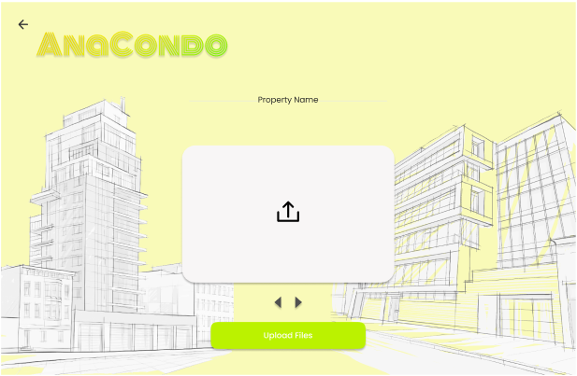
Condo Management Company Administrator Home Page Upload File Page

Steps:
- The condo management company administrator user selects “Upload Files”
- The user drops the files they want in the dropbox
- The user selects “Upload Files” to upload the files to the database
[US-209]: [Property Information]
As a condo management company,
I want to be able to enter and modify information concerning units, parking spots and lockers in a building,
So that I can properly manage my properties.

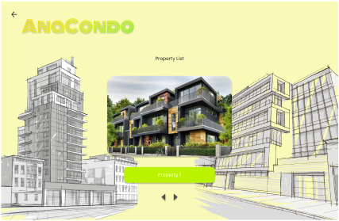
Condo Management Company Administrator Home Page Property List Page
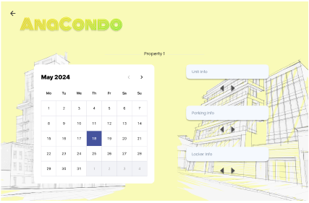
Property Information Page
Steps:
- The condo management company administrator user selects “My Properties”
- The user selects the specific property they will modify information about
- The user enters the information they want for any facilities in their property

[US-210]: [Send Registration Keys]
As a condo management company administrator, I want to digitally send the registration keys to the respective units of the unit owners or rental users, so that I may maintain contact and oversee condo units.
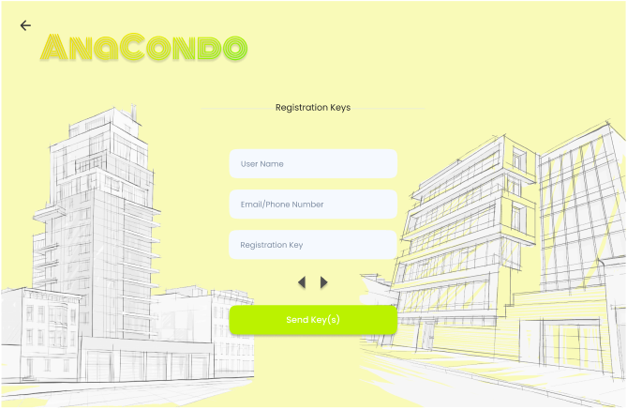
Condo Management Company Administrator Home Page Send Registration Key Page

Steps:
- The condo management company administrator user selects “Send Registration Keys”
- The user fills the form for the user they wish to send a key to
- The user can fill multiple forms to send registration keys to
- The user selects “Send Key(s)” to send registration keys to all other specified users

[US-311]: [Reserving A Common Facility]
As an occupant, I want to receive the availability of and reserve a common facility in a calendar like interface, so that I may enjoy the amenities offered by the condo company.
Rental User Home Page Property List Page
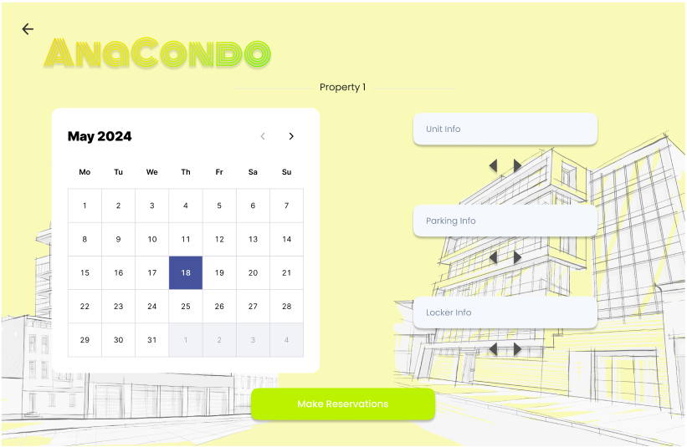
Property Facilities Information Page
Steps:
- The Rental user selects “Reservations”
- The user selects the property they want to reserve a facility from
- The user selects the facility they want to reserve
- The user selects “Make Reservations” to confirm the reservation and lock in the time slot given to it

[US-312]: [Setting Up A Common Facility]
As a condo management company administrator, I want to set up and create new common facility interfaces whereby condo owners and rental users may access the interface to reserve a slot for the facilities offered so that we may continue to grow a loyal customer base and stellar reputation.
Condo Management Company Administrator Home Page Property List Page
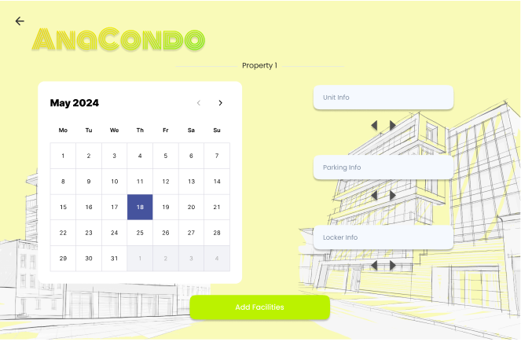
Property Facilities Page
Steps:
- The condo management company administrator user selects “Facilities”
- The user selects the property they want to add a facility to
- The user enters the information of the facility they want to add
- The user selects “Add Facilities” to confirm the information submitted

[US-313]: [Public User Notification]
As a public user, I want to be notified of any activities in my submitted or assigned requests in a common interface or page so that I may easily access and monitor the latest activities in a timely manner.
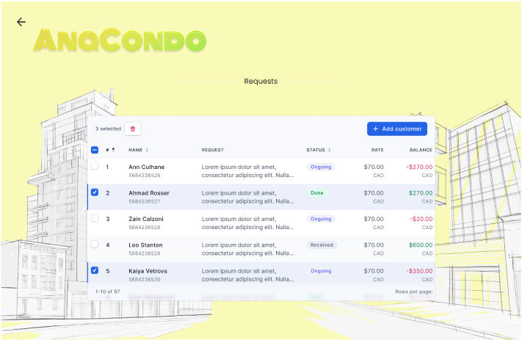
Public User Home Page Notifications Page
Steps:
- The public user selects “notification”
- The user views information about any requests submitted or received

